
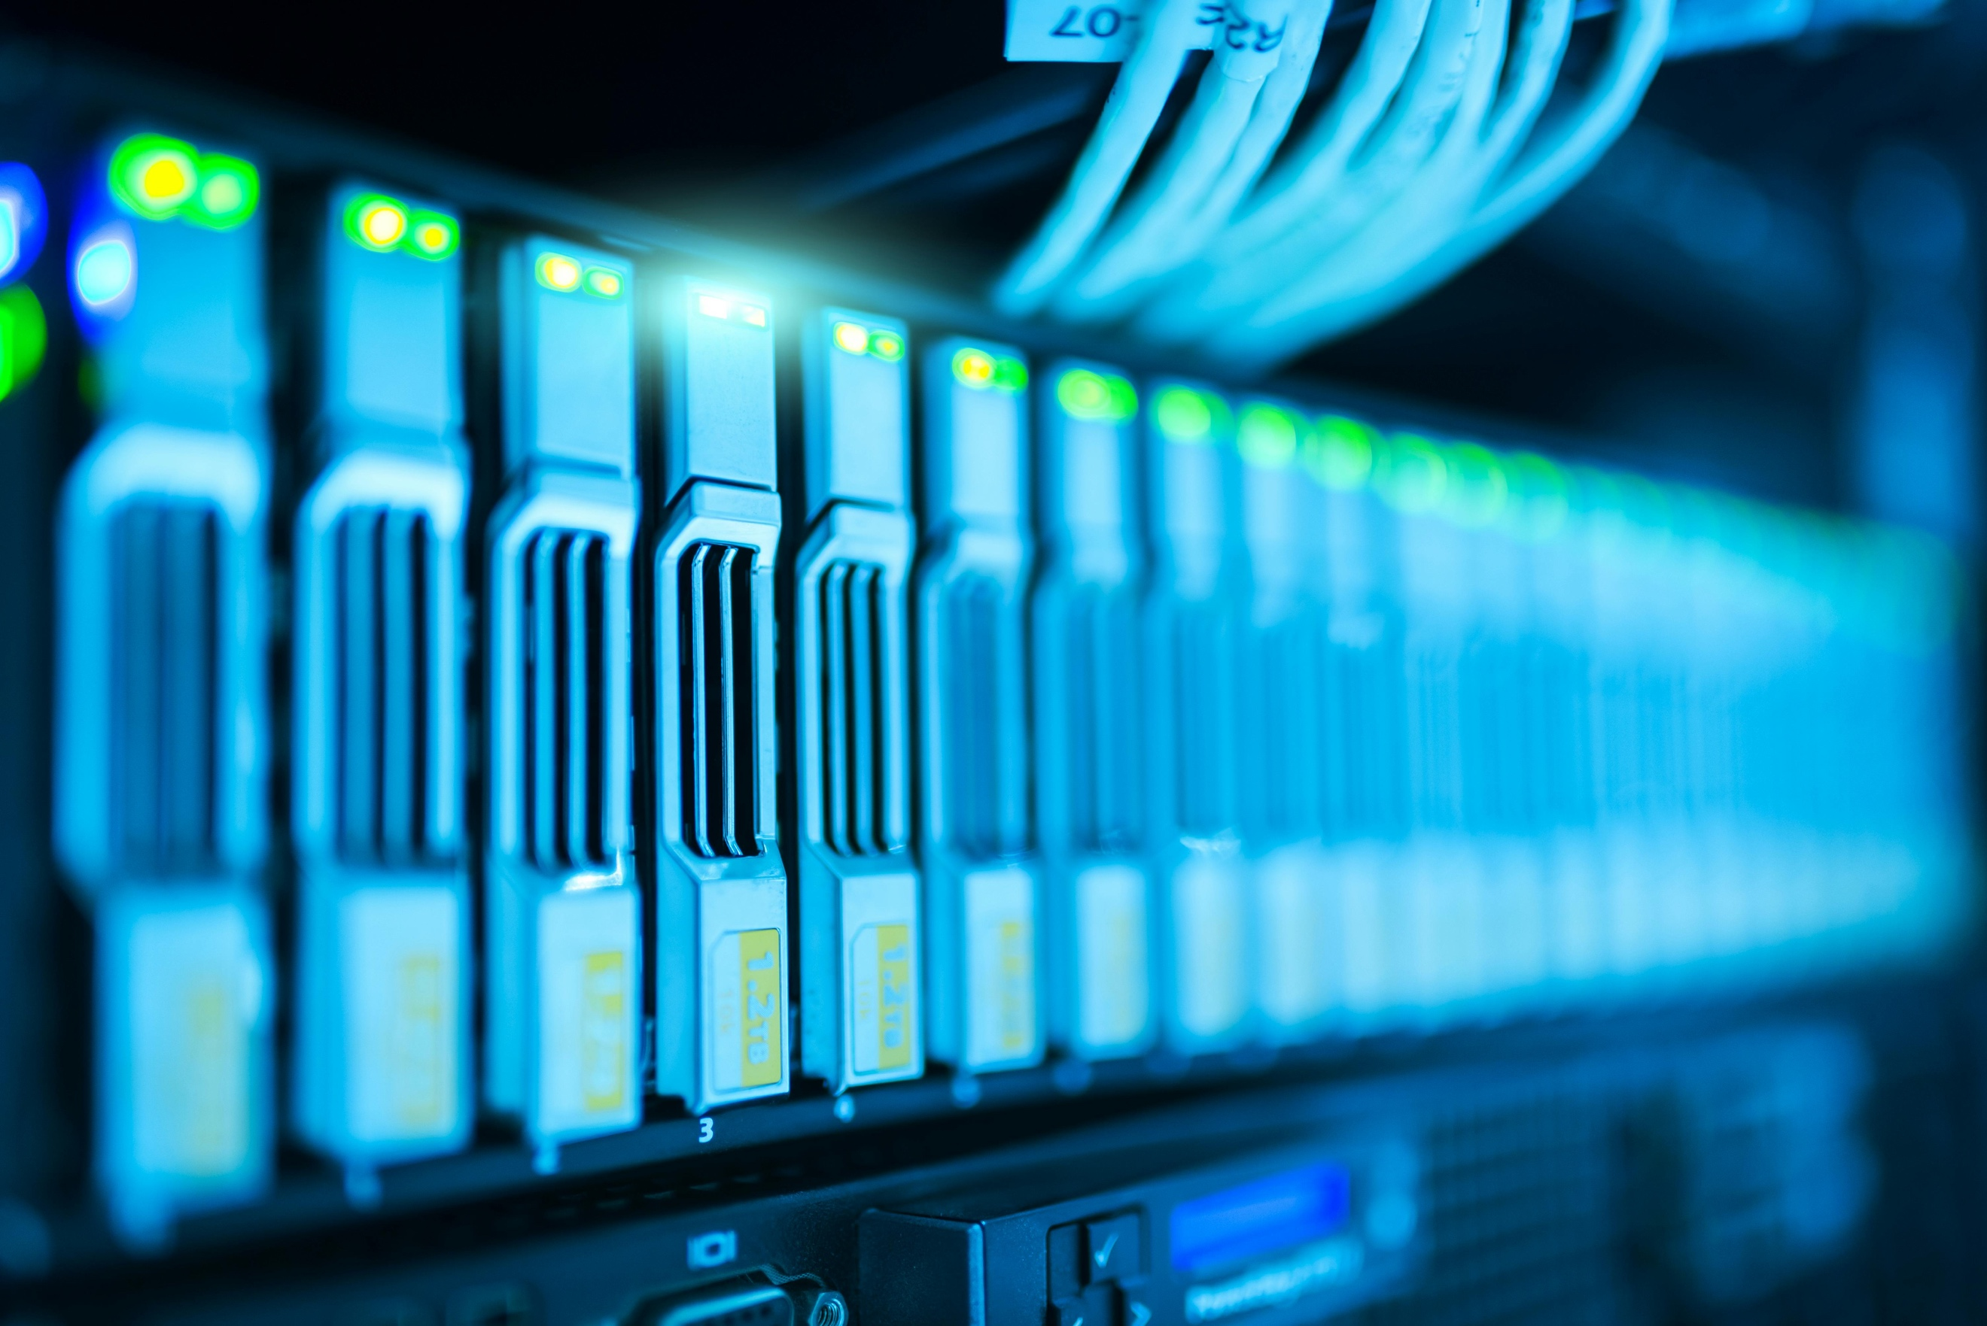

Configuring Multi-Area OSPF Network
Eric Xia

Purpose
The purpose of this lab is to configure OSPF between neighbouring networks. Additionally, this also adds in multi-area OSPFv2 and OSPFv3 for long-distance simulation, and multi-layer switches for more complex routing scenarios.

Background
OSPF, which stands for Open Shortest Path First, is a widely used interior gateway routing protocol that has played a critical role in the evolution of IP networking. It was initially developed in the late 1980s by the Internet Engineering Task Force (IETF) as a replacement for the aging Routing Information Protocol (RIP). At the time, RIP had been a simple and reliable protocol for basic network routing, but it was increasingly unable to handle the demands of growing and more complex network topologies. RIP’s limitations, including its relatively slow convergence time, maximum hop count, and lack of support for advanced routing features, made it inadequate for modern networks. As a result, the development of a more sophisticated routing protocol became necessary.
OSPF addressed these limitations by providing a more advanced method for discovering network paths and calculating the best routes for packet delivery. Unlike RIP, which is a distance-vector protocol that relies on hop counts, OSPF is a link-state protocol. This means that each OSPF-enabled router maintains a complete map of the network, known as a link-state database. To determine the shortest and most efficient paths through the network, OSPF uses Dijkstra’s algorithm, which calculates the least-cost path from a router to all other routers in the network. This approach allows OSPF to respond more quickly to network changes and to scale efficiently across large and complex network environments.
Another major advancement in OSPF is its support for load balancing through Equal-Cost Multipath (ECMP) routing. With ECMP, multiple paths of equal cost to a destination can be used simultaneously, improving bandwidth utilization and providing redundancy in case of link failures. Additionally, OSPF included built-in authentication mechanisms that ensured routers exchanged routing information securely, a significant improvement over RIP, which had no native security features. This made OSPF both faster and more secure, offering a better foundation for enterprise networks that required reliability and data integrity.
The original version of OSPF, known as OSPFv2, was specifically designed for IPv4 routing. OSPFv2 also introduced the concept of areas, which allowed network administrators to divide an OSPF network into hierarchical segments. This supported both single-area and multi-area network designs, reducing the size of the routing table and limiting the scope of network updates to improve efficiency. OSPFv2 also used Link-State Advertisements (LSAs) to communicate the state of each router and its connected links. LSAs contained critical information such as IP addresses and network topology, allowing each router to build an accurate and up-to-date map of the network.
With the eventual development and deployment of IPv6, OSPF needed to evolve to accommodate the new protocol. This led to the introduction of OSPFv3 in 1998, which was designed to handle IPv6 routing while retaining many of the features that made OSPFv2 successful. OSPFv3 includes several notable differences from its predecessor. First, while OSPFv3 is primarily an IPv6 protocol, it can also route IPv4 traffic through extensions, making it versatile in mixed network environments. Second, instead of using OSPF’s internal authentication methods, OSPFv3 relies on IPsec to provide robust security, offering stronger protection for routing information. Third, OSPFv3 allows multiple OSPF processes to run on the same network interface, which provides additional flexibility in network design. Finally, it uses an IPv6 header rather than an IPv4 header for packet encapsulation, reflecting the protocol’s native support for IPv6.
Overall, the development of OSPF represented a major leap forward in the field of IP routing. Its combination of link-state routing, efficient path calculation, support for hierarchical network structures, load balancing, and security features made it a significant improvement over RIP. Even decades after its introduction, OSPF remains a foundational routing protocol, widely implemented and actively maintained across both enterprise and service provider networks. Its continued relevance demonstrates the robustness and forward-thinking design of the protocol, which successfully adapted to the transition from IPv4 to IPv6 while maintaining high levels of efficiency, scalability, and security.

Lab Summary
In this lab, my lab partner and I set up multi-area OSPFv2 and OSPFv3, configuring 5 routers and 2 multi-layer switches (Layer 3 switches), for a total of 7 devices. Area 0 is the backbone, with 3 devices in total, with one central device, and 2 devices that border upon 2 other areas (Areas 1 and 2). In Areas 1 and 2, there are the 2 border devices that are linked between Area 0 and Area 1 or 2, and then linked to another router, which is then linked to a multi-layer switch on each end. Each of the devices are configured with one or two IPv4 and an IPv6 address depending on how many ports are linked to the networks. Then we configured with the same router ID for both OSPFv2 and OSPFv3 on process ID 1, along with linking network statements into the interfaces that have the IPv4 and IPv6 addresses. We also put in basic security commands, such as a MOTD banner and a line con 0 password. Afterwards, we test out whether the commands work by pinging to confirm the connection is established and then traceroute to confirm that the connection is going through each OSPF area thru the backbone.

Lab Commands
Standard commands (OSPF commands only):
Router3(config)#router ospf 1
Router3(config-router)#router-id 3.3.3.3
Router3(config)#ipv6 router ospf 1
Router3(config-rtr)#router-id 3.3.3.3
Router3(config)#ipv6 unicast-routing
Router3(config-if)#ip address 192.168.2.2 255.255.255.252
Router3(config-if)#ipv6 address 2001:db8:67:abcd::2/36
Switch(config)# sdm prefer dual-ipv4-and-ipv6 default
Router3(config)#router ospf 1
Router3(config-router)#router-id 3.3.3.3
Router3(config-if)#ip ospf 1 area 0
Router3(config-if)#ipv6 ospf 1 area 0
For the multi-layer switches:
switch1(config-if)#no switchport
Network Diagrams
IPv4 Network Topology: 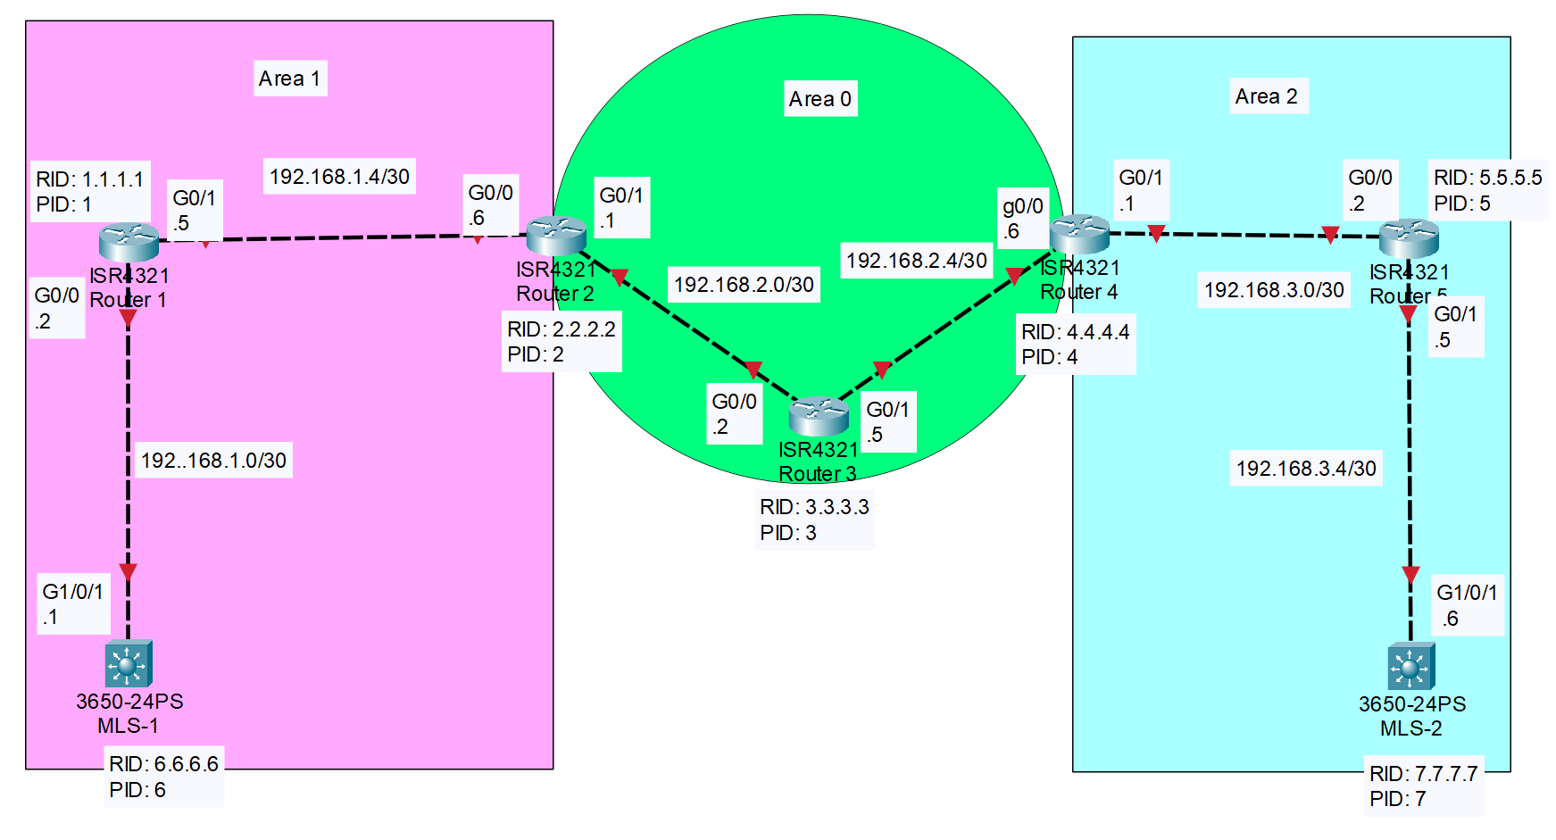
IPv6 Network Topology: 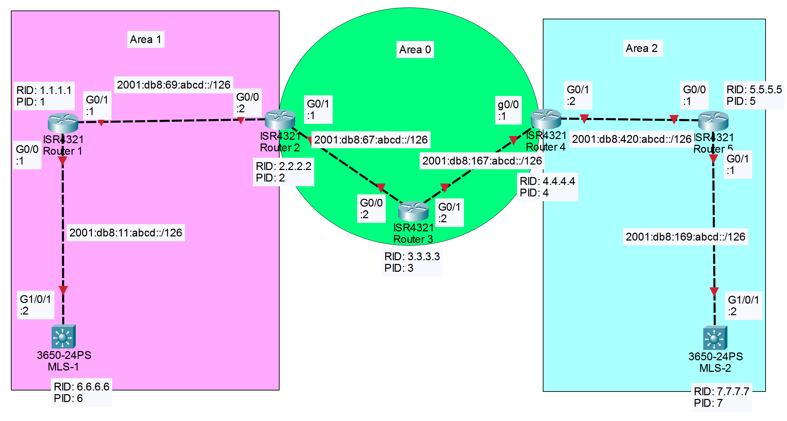

Step-by-step Guide Perchance
Step 0
There are a few things that you would want to mind. Perchance. This includes the proper wiring connections into the right ports on the 5 routers and 2 switches.
Boot into the router. When, prompted to enter the configuration dialog, type in No, n, or no. It will always bypass the dialogue. Perchance.
Just in case, reload the router again if there is a configuration on it already, and you want to get rid of it:
Router>enable
Router#reload
Proceed with reload? [confirm]

*Sep 11 09:03:11.169: %SYS-5-RELOAD: Reload requested by console. Reload Reason: Reload Command.
*NOTE: you could just power cycle the router by using the power button. That is, if you have access to it, perchance.
After reloading the router, you’re prompted with the configuration dialog, which you do again. This time, you’ll know that the configs are empty, and you’re free to start configuring the routers.
Step 1
Now, go back into enable, and now, enter configure mode by using the configure terminal command:
Router>en
Router#conf t
Now, set a hostname for the router.
Router(config)#hos [insert hostname]
[insert hostname](config)#
*NOTE: in this case, we’ll be using rx as the hostname, so that’ll be what you see for the commands. Also, it’s normal for me to shorten the commands by a ton, so you’ll see that here. Perchance.
rx(config)#
Now, it’s time to configure basic security on the router. Let’s first start off with a banner motd command, and then set a line con 0 password along with encrypting it with service password-encryption:
rx(config)#banner motd &pls don’t enter (°-°)&
rx(config)#lin co 0
rx(config-line)#pass cisco
rx(config-line)#exi
rx(config)#ser password-e
Now, you’ve set the router’s basic security and passwords. Perchance.
Step 2
Time to configure basic IP configurations! Perchance.
First, get into each of the interfaces that you’re going to use and are connected to each other. On the routers, it’s g0/0/0 and g0/0/1. Also, remember to set ipv6 unicast-routing for the ipv6 configurations to go thru properly.
rx(config)#ipv u
rx(config)#int g0/0/0
rx(config-if)#ip add 169.67.167.69 255.255.255.252
*NOTE: use the IP addresses that you use and chose for that specific port. Subnetting will always be .252, or /30. Same goes for IPv6, where the subnetting will always be /126, but the address will be different.
rx(config-if)#ipv add 2001:69:67:420::1/126
rx(config-if)#no sh
Repeat the same on g0/0/1. Perchance.
Step 3
Time to work on the OSPF configuration.
Exit out of the interface, the go into router ospf. Then, set the router id. Do the same in ipv6 router ospf.
rx(config-int)#exi
rx(config)#router ospf 1
rx(config-router)#router- [x.x.x.x]
rx(config-router)#ipv router os 1
rx(config-rtr)#router- [x.x.x.x]
*NOTE: [x.x.x.x] is different for each router. For example, router 4 has an id of 4.4.4.4, while router 2 has an id of 2.2.2.2.
Now, it’s time to put the network statements into the interfaces. I use [a] and [b] for the OSPF areas. If the router is only in a single area, then [a] and [b] are the same. Make sure to refresh the router ospf process afterwards and save the config into a file that is NOT running-config, unless if the router is your own and you need OSPF on the router by default. Perchance.
rx(config-rtr)#int g0/0/0
rx(config-if)#ip os 1 a [a]
rx(config-if)#ipv os 1 a [a]
rx(config-if)#int g0/0/1
rx(config-if)#ip os 1 a [b]
rx(config-if)#ipv os 1 a [b]
rx(config-if)#end
rx#cle ip os pro
rx#copy ru flash:[insert filename here]
OR
rx#copy ru st
(if you can do so and won’t get in trouble doing so)
Congratulations! You’ve set a single router up. Now, make sure to repeat these another 4 times on each different router. Now, the configs are mostly the same, besides the hostname, ip addresses and ipv6 addresses, and OSPF areas. Perchance.
Step 4
Time to configure the 2 switches in the network. Yipee. Perchance.
Please first do reset the switches (refer to Step 0, since the process is the same).
Here are the commands (just in case you’re too lazy to go back to Step 0):
Switch>enable
Switch#reload
Proceed with reload? [confirm]
*Sep 11 09:03:11.169: %SYS-5-RELOAD: Reload requested by console. Reload Reason: Reload Command.
Step 5
Alright, now you’ve finished that, it’s time to configure the basic switch security configs.
It’s the same as before, but here they are, perchance:
Switch>en
Switch#conf t
Now, set a hostname for the router.
Switch(config)#hos sd
sd(config)#banner motd &pls don’t enter (°-°)&
sd(config)#lin co 0
sd(config-line)#pass cisco
sd(config-line)#exi
sd(config)#ser password-e
Step 6
Time to configure basic IP configurations… again. Perchance.
On the switches, somehow, it’s g1/0/1. This is probably because I’m using a multi-layer switch, also known as a layer 3 switch. This allows for ipv6 address configuration and most router configs. If you do end up using standard single-layer switches (layer 2 switches), then the port will be f0/1. Again, I just used example addresses here. One more thing here, it’s that you’re going to use the ports and configure ip and ipv6 addresses onto them, then the no switchport command is needed. Perchance.
sd(config)#ipv u
sd(config)#int g1/0/1
sd(config-if)#no swi
sd(config-if)#ip add 169.69.167.14 255.255.255.252
sd(config-if)#ipv add 2001:169:167:420::1/126
sd(config-if)#no sh
Step 7
It’s OSPF config time. The process is mostly the same, but with less stuff.
sd(config-int)#exi
sd(config)#router ospf 1
sd(config-router)#router- [x.x.x.x]
sd(config-router)#ipv router os 1
sd(config-rtr)#router- [x.x.x.x]
*NOTE: Yes, switches, out of all things, will need router-IDs. Surprised? Perchance.
sd(config-rtr)#int g1/0/1
sd(config-if)#ip os 1 a [n]
sd(config-if)#ipv os 1 a [n]
sd(config-if)#end
sd#cle ip os pro
sd#copy ru flash:[insert filename here]
OR
sd#copy ru st
(if you can do so and won’t get in trouble doing so)
It’s time to do testing to see if you really did set the stuff properly.
Step 8
Testing time!
On routers, you only really need to test out if the OSPF areas are working or not.
Using traceroute on switch, you will get something like this:
Tracing the route to 192.168.3.6
VRF info: (vrf in name/id, vrf out name/id)
1 192.168.1.2 4 msec 4 msec 0 msec
2 192.168.1.6 0 msec 4 msec 0 msec
3 192.168.2.2 0 msec 4 msec 0 msec
4 192.168.2.6 0 msec 4 msec 0 msec
5 192.168.3.2 4 msec 0 msec 4 msec
6 192.168.3.6 112 msec 4 msec *
If you first traceroute, then you don’t need to ping afterwards.
Then, you go onto the routers to check if the areas are working and valid or not.
OSPF Router with ID (6.6.6.6) (Process ID 1)
Router Link States (Area 1)
Link ID ADV Router Age Seq# Checksum Link count
1.1.1.1 1.1.1.1 755 0x80000005 0x007EE0 2
2.2.2.2 2.2.2.2 101 0x80000004 0x00A797 1
6.6.6.6 6.6.6.6 745 0x80000003 0x001118 1
Net Link States (Area 1)
Link ID ADV Router Age Seq# Checksum
192.168.1.2 1.1.1.1 756 0x80000001 0x00EDC2
192.168.1.5 1.1.1.1 816 0x80000001 0x0007B6
Summary Net Link States (Area 1)
Link ID ADV Router Age Seq# Checksum
192.168.2.0 2.2.2.2 101 0x80000001 0x007D4E
192.168.2.4 2.2.2.2 57 0x80000001 0x005F67
192.168.3.0 2.2.2.2 51 0x80000001 0x008642
192.168.3.4 2.2.2.2 51 0x80000001 0x00685B
You also should check ip routes on both switches and routers. It should look something like this:
192.168.1.0/30 is subnetted, 2 subnets
O IA 192.168.1.0 [110/6] via 192.168.3.5, 00:21:27, GigabitEthernet1/0/1
O IA 192.168.1.4 [110/5] via 192.168.3.5, 00:21:27, GigabitEthernet1/0/1
192.168.2.0/30 is subnetted, 2 subnets
O IA 192.168.2.0 [110/4] via 192.168.3.5, 00:21:27, GigabitEthernet1/0/1
O IA 192.168.2.4 [110/3] via 192.168.3.5, 00:22:07, GigabitEthernet1/0/1
192.168.3.0/24 is variably subnetted, 3 subnets, 2 masks
O 192.168.3.0/30 [110/2] via 192.168.3.5, 00:23:30, GigabitEthernet1/0/1
C 192.168.3.4/30 is directly connected, GigabitEthernet1/0/1
L 192.168.3.6/32 is directly connected, GigabitEthernet1/0/1
Ipv6 routes look similar, but instead of having an O for OSPF, it has an Oi for OSPFv3 instead. Here are what the pings and traceroutes look like for ipv6:
Router2#ping 2001:db8:11::2
Type escape sequence to abort.
Sending 5, 100-byte ICMP Echos to 2001:DB8:11:ABCD::2, timeout is 2 seconds:
!!!!!
Success rate is 100 percent (5/5), round-trip min/avg/max = 1/5/16 ms
s2#traceroute 2001:db8:11::2
Type escape sequence to abort.
Tracing the route to 2001:DB8:11:ABCD::2
1 2001:DB8:169:ABCD::1 0 msec 0 msec 0 msec
2 2001:DB8:420:ABCD::2 4 msec 0 msec 0 msec
3 2001:DB8:167:ABCD::2 4 msec 0 msec 0 msec
4 2001:DB8:67:ABCD::1 4 msec 0 msec 4 msec
5 2001:DB8:69:ABCD::1 0 msec 4 msec 0 msec
6 2001:DB8:11:ABCD::2 24 msec 4 msec 0 msec
s2#
Congratulations! You’ve completed the setup for OSPFv2 and OSPFv3 for an entire backbone network, and verified that it works.

Lab Configurations
R1:
Current configuration : 1661 bytes
! Last configuration change at 18:15:28 UTC Fri Sep 12 2025
version 16.9
service timestamps debug datetime msec
service timestamps log datetime msec
platform qfp utilization monitor load 80
platform punt-keepalive disable-kernel-core
hostname Router1
boot-start-marker
boot-end-marker
vrf definition Mgmt-intf
address-family ipv4
exit-address-family
address-family ipv6
exit-address-family
no aaa new-model
login on-success log
subscriber templating
ipv6 unicast-routing
multilink bundle-name authenticated
license udi pid ISR4321/K9 sn FLM2408005M
no license smart enable
diagnostic bootup level minimal
spanning-tree extend system-id
redundancy
mode none
interface GigabitEthernet0/0/0
ip address 192.168.1.2 255.255.255.252
ip ospf 1 area 1
negotiation auto
ipv6 address 2001:DB8:11:ABCD::1/126
ipv6 ospf 1 area 1
interface GigabitEthernet0/0/1
ip address 192.168.1.5 255.255.255.252
ip ospf 1 area 1
negotiation auto
ipv6 address 2001:DB8:69:ABCD::1/126
ipv6 ospf 1 area 1
interface GigabitEthernet0/2/0
no ip address
negotiation auto
interface GigabitEthernet0/2/1
no ip address
negotiation auto
interface GigabitEthernet0
vrf forwarding Mgmt-intf
no ip address
negotiation auto
router ospf 1
router-id 1.1.1.1
ip forward-protocol nd
no ip http server
ip http secure-server
ip tftp source-interface GigabitEthernet0
ipv6 router ospf 1
router-id 1.1.1.1
control-plane
banner motd ^Cdo not enter^C
line con 0
password cisco
login
transport input none
stopbits 1
line aux 0
stopbits 1
line vty 0 4
login
End
R2:
Current configuration : 1661 bytes
! Last configuration change at 17:42:35 UTC Fri Sep 12 2025
version 16.9
service timestamps debug datetime msec
service timestamps log datetime msec
platform qfp utilization monitor load 80
platform punt-keepalive disable-kernel-core
hostname Router2
boot-start-marker
boot-end-marker
vrf definition Mgmt-intf
address-family ipv4
exit-address-family
address-family ipv6
exit-address-family
no aaa new-model
login on-success log
subscriber templating
ipv6 unicast-routing
multilink bundle-name authenticated
license udi pid ISR4321/K9 sn FLM24060912
no license smart enable
diagnostic bootup level minimal
spanning-tree extend system-id
redundancy
mode none
interface GigabitEthernet0/0/0
ip address 192.168.1.6 255.255.255.252
ip ospf 1 area 1
negotiation auto
ipv6 address 2001:DB8:69:ABCD::2/126
ipv6 ospf 1 area 1
interface GigabitEthernet0/0/1
ip address 192.168.2.1 255.255.255.252
ip ospf 1 area 0
negotiation auto
ipv6 address 2001:DB8:67:ABCD::1/126
ipv6 ospf 1 area 0
interface GigabitEthernet0/2/0
no ip address
negotiation auto
interface GigabitEthernet0/2/1
no ip address
negotiation auto
interface GigabitEthernet0
vrf forwarding Mgmt-intf
no ip address
negotiation auto
router ospf 1
router-id 2.2.2.2
ip forward-protocol nd
no ip http server
ip http secure-server
ip tftp source-interface GigabitEthernet0
ipv6 router ospf 1
router-id 2.2.2.2
control-plane
banner motd ^Cdo not enter^C
line con 0
password cisco
login
transport input none
stopbits 1
line aux 0
stopbits 1
line vty 0 4
login
end
R3:
Current configuration : 1618 bytes
! Last configuration change at 18:33:50 UTC Thu Sep 11 2025
version 16.9
service timestamps debug datetime msec
service timestamps log datetime msec
no platform punt-keepalive disable-kernel-core
hostname Router3
boot-start-marker
boot-end-marker
vrf definition Mgmt-intf
address-family ipv4
exit-address-family
address-family ipv6
exit-address-family
no aaa new-model
ipv6 unicast-routing
subscriber templating
multilink bundle-name authenticated
license udi pid ISR4321/K9 sn FDO214420G7
spanning-tree extend system-id
redundancy
mode none
vlan internal allocation policy ascending
interface GigabitEthernet0/0/0
ip address 192.168.2.2 255.255.255.252
ip ospf 1 area 0
negotiation auto
ipv6 address 2001:DB8:67:ABCD::2/126
ipv6 ospf 1 area 0
interface GigabitEthernet0/0/1
ip address 192.168.2.5 255.255.255.252
ip ospf 1 area 0
negotiation auto
ipv6 address 2001:DB8:167:ABCD::2/126
ipv6 ospf 1 area 0
interface Serial0/1/0
no ip address
shutdown
interface Serial0/1/1
no ip address
shutdown
interface GigabitEthernet0
vrf forwarding Mgmt-intf
no ip address
shutdown
negotiation auto
interface Vlan1
no ip address
shutdown
router ospf 1
router-id 3.3.3.3
ip forward-protocol nd
no ip http server
no ip http secure-server
ip tftp source-interface GigabitEthernet0
ipv6 router ospf 1
router-id 3.3.3.3
control-plane
line con 0
stopbits 1
line aux 0
stopbits 1
line vty 0 4
login
End
R4
Current configuration : 1609 bytes
! Last configuration change at 17:27:02 UTC Fri Sep 12 2025
version 16.9
service timestamps debug datetime msec
service timestamps log datetime msec
service password-encryption
no platform punt-keepalive disable-kernel-core
hostname R4
boot-start-marker
boot-end-marker
vrf definition Mgmt-intf
address-family ipv4
exit-address-family
address-family ipv6
exit-address-family
no aaa new-model
ipv6 unicast-routing
subscriber templating
multilink bundle-name authenticated
license udi pid ISR4321/K9 sn FDO211216BL
spanning-tree extend system-id
redundancy
mode none
vlan internal allocation policy ascending
interface GigabitEthernet0/0/0
ip address 192.168.3.1 255.255.255.252
ip ospf 1 area 0
negotiation auto
ipv6 address 2001:DB8:420:ABCD::2/126
ipv6 ospf 1 area 0
interface GigabitEthernet0/0/1
ip address 192.168.2.6 255.255.255.252
negotiation auto
ipv6 address 2001:DB8:167:ABCD::1/126
ipv6 ospf 1 area 2
interface Serial0/1/0
no ip address
interface Serial0/1/1
no ip address
interface GigabitEthernet0
vrf forwarding Mgmt-intf
no ip address
negotiation auto
interface Vlan1
no ip address
router ospf 1
router-id 4.4.4.4
ip forward-protocol nd
no ip http server
no ip http secure-server
ip tftp source-interface GigabitEthernet0
ipv6 router ospf 1
router-id 4.4.4.4
control-plane
line con 0
password 7 1511021F0725
stopbits 1
line aux 0
stopbits 1
line vty 0 4
login
end
R5
Current configuration : 1516 bytes
version 16.9
service timestamps debug datetime msec
service timestamps log datetime msec
no platform punt-keepalive disable-kernel-core
hostname Router
boot-start-marker
boot-end-marker
vrf definition Mgmt-intf
address-family ipv4
exit-address-family
address-family ipv6
exit-address-famil
no aaa new-model
ipv6 unicast-routing
subscriber templating
multilink bundle-name authenticated
license udi pid ISR4321/K9 sn FDO214421CF
spanning-tree extend system-id
redundancy
mode none
vlan internal allocation policy ascendin
interface GigabitEthernet0/0/0
ip address 192.168.3.2 255.255.255.252
ip ospf 1 area 2
negotiation auto
ipv6 address 2001:DB8:420:ABCD::1/126
ipv6 ospf 1 area 2
interface GigabitEthernet0/0/1ip address 192.168.3.5 255.255.255.252
ip ospf 1 area 2
negotiation auto
ipv6 address 2001:DB8:169:ABCD::1/126
ipv6 ospf 1 area 2
interface Serial0/1/0
no ip address
interface Serial0/1/
no ip address
interface GigabitEthernet0
vrf forwarding Mgmt-intf
no ip addres
negotiation auto
interface Vlan1
no ip address
router ospf 1
router-id 5.5.5.5
ip forward-protocol nd
no ip http server
no ip http secure-server
ip tftp source-interface GigabitEthernet0
ipv6 router ospf 1
router-id 5.5.5.5
control-plane
line con 0
stopbits 1
line aux 0
stopbits 1
line vty 0 4
login
End
MLS1
Current configuration : 9213 bytes
! Last configuration change at 17:38:44 UTC Fri Sep 12 2025
version 16.12
no service pad
service timestamps debug datetime msec
service timestamps log datetime msec
! Call-home is enabled by Smart-Licensing.
service call-home
platform punt-keepalive disable-kernel-core
hostname switch1
vrf definition Mgmt-vrf
address-family ipv4
exit-address-family
address-family ipv6
exit-address-family
no aaa new-model
switch 1 provision c9200l-24t-4g
ip routing
login on-success log
ipv6 unicast-routing
call-home
! If contact email address in call-home is configured as sch-smart-licensing@cisco.com
! the email address configured in Cisco Smart License Portal will be used as contact email address to send SCH notifications.
contact-email-addr sch-smart-licensing@cisco.com
profile "CiscoTAC-1"
active
destination transport-method http
no destination transport-method email
no device-tracking logging theft
diagnostic bootup level minimal
spanning-tree mode rapid-pvst
spanning-tree extend system-id
memory free low-watermark processor 10055
redundancy
mode sso
interface GigabitEthernet0/0
vrf forwarding Mgmt-vrf
no ip address
shutdown
negotiation auto
interface GigabitEthernet1/0/1
no switchport
ip address 192.168.1.1 255.255.255.252
ip ospf 1 area 1
ipv6 address 2001:DB8:11:ABCD::2/126
ipv6 ospf 1 area 1
interface GigabitEthernet1/0/2
interface GigabitEthernet1/0/3
interface GigabitEthernet1/0/4
interface GigabitEthernet1/0/5
interface GigabitEthernet1/0/6
interface GigabitEthernet1/0/7
interface GigabitEthernet1/0/8
interface GigabitEthernet1/0/9
interface GigabitEthernet1/0/10
interface GigabitEthernet1/0/11
interface GigabitEthernet1/0/12
interface GigabitEthernet1/0/13
interface GigabitEthernet1/0/14
interface GigabitEthernet1/0/15
interface GigabitEthernet1/0/16
interface GigabitEthernet1/0/17
interface GigabitEthernet1/0/18
interface GigabitEthernet1/0/19
interface GigabitEthernet1/0/20
interface GigabitEthernet1/0/21
interface GigabitEthernet1/0/22
interface GigabitEthernet1/0/23
interface GigabitEthernet1/0/24
interface GigabitEthernet1/1/1
interface GigabitEthernet1/1/2
interface GigabitEthernet1/1/3
interface GigabitEthernet1/1/4
interface Vlan1
no ip address
router ospf 1
router-id 6.6.6.6
ip forward-protocol nd
ip http server
ip http authentication local
ip http secure-server
ipv6 router ospf 1
router-id 6.6.6.6
control-plane
service-policy input system-cpp-policy
line con 0
password cisco
login
stopbits 1
line aux 0
stopbits 1
line vty 0 4
login
line vty 5 15
login
end
MLS2
Current configuration : 8657 bytes
! Last configuration change at 18:06:46 UTC Fri Sep 12 2025
version 16.9
no service pad
service timestamps debug datetime msec
service timestamps log datetime msec
! Call-home is enabled by Smart-Licensing.
service call-home
no platform punt-keepalive disable-kernel-core
hostname s2
vrf definition Mgmt-vrf
address-family ipv4
exit-address-family
address-family ipv6
exit-address-family
no aaa new-model
switch 1 provision c9200l-24t-4g
ip routing
ip arp entry learn 10240
login on-success log
ipv6 unicast-routing
call-home
! If contact email address in call-home is configured as sch-smart-licensing@cisco.com
! the email address configured in Cisco Smart License Portal will be used as contact email address to send SCH notifications.
contact-email-addr sch-smart-licensing@cisco.com
profile "CiscoTAC-1"
active
destination transport-method http
no destination transport-method email
crypto pki trustpoint SLA-TrustPoint
enrollment pkcs12
revocation-check crl
crypto pki trustpoint TP-self-signed-2221393201
enrollment selfsigned
subject-name cn=IOS-Self-Signed-Certificate-2221393201
revocation-check none
rsakeypair TP-self-signed-2221393201
license boot level network-essentials addon dna-essentials
diagnostic bootup level minimal
spanning-tree mode rapid-pvst
spanning-tree extend system-id
redundancy
mode sso
policy-map system-cpp-policy
interface GigabitEthernet0/0
vrf forwarding Mgmt-vrf
no ip address
shutdown
negotiation auto
interface GigabitEthernet1/0/1
no switchport
ip address 192.168.3.6 255.255.255.252
ip ospf 1 area 2
ipv6 address 2001:DB8:169:ABCD::2/126
ipv6 ospf 1 area 2
interface GigabitEthernet1/0/2
interface GigabitEthernet1/0/3
interface GigabitEthernet1/0/4
interface GigabitEthernet1/0/5
interface GigabitEthernet1/0/6
interface GigabitEthernet1/0/7
interface GigabitEthernet1/0/8
interface GigabitEthernet1/0/9
interface GigabitEthernet1/0/10
interface GigabitEthernet1/0/11
interface GigabitEthernet1/0/12
interface GigabitEthernet1/0/13
interface GigabitEthernet1/0/14
interface GigabitEthernet1/0/15
interface GigabitEthernet1/0/16
interface GigabitEthernet1/0/17
interface GigabitEthernet1/0/18
interface GigabitEthernet1/0/19
interface GigabitEthernet1/0/20
interface GigabitEthernet1/0/21
interface GigabitEthernet1/0/22
interface GigabitEthernet1/0/23
interface GigabitEthernet1/0/24
interface GigabitEthernet1/1/1
interface GigabitEthernet1/1/2
interface GigabitEthernet1/1/3
interface GigabitEthernet1/1/4
interface Vlan1
no ip address
shutdown
router ospf 1
router-id 7.7.7.7
ip forward-protocol nd
ip http server
ip http authentication local
ip http secure-server
ipv6 router ospf 1
router-id 7.7.7.7
control-plane
service-policy input system-cpp-policy
line con 0
stopbits 1
line aux 0
stopbits 1
line vty 0 4
login
line vty 5 15
login
end

Testing Results
Traceroute from MLS1 to MLS2
OSPFv2
Tracing the route to 192.168.3.6
VRF info: (vrf in name/id, vrf out name/id)
1 192.168.1.2 4 msec 4 msec 0 msec
2 192.168.1.6 0 msec 4 msec 0 msec
3 192.168.2.2 0 msec 4 msec 0 msec
4 192.168.2.6 0 msec 4 msec 0 msec
5 192.168.3.2 4 msec 0 msec 4 msec
6 192.168.3.6 112 msec 4 msec *
OSPFv3 (MLS2 to MLS1)
Type escape sequence to abort.
Tracing the route to 2001:DB8:11:ABCD::2
1 2001:DB8:169:ABCD::1 0 msec 0 msec 0 msec
2 2001:DB8:420:ABCD::2 4 msec 0 msec 0 msec
3 2001:DB8:167:ABCD::2 4 msec 0 msec 0 msec
4 2001:DB8:67:ABCD::1 4 msec 0 msec 4 msec
5 2001:DB8:69:ABCD::1 0 msec 4 msec 0 msec
6 2001:DB8:11:ABCD::2 24 msec 4 msec 0 msec
Multi-area OSPF area database
OSPFv2
OSPF Router with ID (6.6.6.6) (Process ID 1)
Router Link States (Area 1)
Link ID ADV Router Age Seq# Checksum Link count
1.1.1.1 1.1.1.1 755 0x80000005 0x007EE0 2
2.2.2.2 2.2.2.2 101 0x80000004 0x00A797 1
6.6.6.6 6.6.6.6 745 0x80000003 0x001118 1
Net Link States (Area 1)
Link ID ADV Router Age Seq# Checksum
192.168.1.2 1.1.1.1 756 0x80000001 0x00EDC2
192.168.1.5 1.1.1.1 816 0x80000001 0x0007B6
Summary Net Link States (Area 1)
Link ID ADV Router Age Seq# Checksum
192.168.2.0 2.2.2.2 101 0x80000001 0x007D4E
192.168.2.4 2.2.2.2 57 0x80000001 0x005F67
192.168.3.0 2.2.2.2 51 0x80000001 0x008642
192.168.3.4 2.2.2.2 51 0x80000001 0x00685B
OSPFv3
OSPFv3 Router with ID (2.2.2.2) (Process ID 1)

Router Link States (Area 0)

ADV Router Age Seq# Fragment ID Link count Bits
2.2.2.2 152 0x80000006 0 1 B
3.3.3.3 157 0x80000008 0 2 None
4.4.4.4 158 0x80000009 0 1 B

Net Link States (Area 0)

ADV Router Age Seq# Link ID Rtr count
3.3.3.3 162 0x80000001 6 2
4.4.4.4 165 0x80000001 6 2

Inter Area Prefix Link States (Area 0)

ADV Router Age Seq# Prefix
2.2.2.2 156 0x80000001 2001:DB8:69:ABCD::/126
2.2.2.2 156 0x80000002 2001:DB8:11:ABCD::/126
4.4.4.4 205 0x80000001 2001:DB8:169:ABCD::/126
4.4.4.4 205 0x80000001 2001:DB8:420:ABCD::/126

Link (Type-8) Link States (Area 0)

ADV Router Age Seq# Link ID Interface
2.2.2.2 152 0x80000002 7 Gi0/0/1
3.3.3.3 209 0x80000002 6 Gi0/0/1

Intra Area Prefix Link States (Area 0)

ADV Router Age Seq# Link ID Ref-lstype Ref-LSID
3.3.3.3 162 0x80000001 6144 0x2002 6
4.4.4.4 165 0x80000001 6144 0x2002 6

Router Link States (Area 1)

ADV Router Age Seq# Fragment ID Link count Bits
1.1.1.1 157 0x8000000E 0 2 None
2.2.2.2 154 0x80000007 0 1 B
6.6.6.6 271 0x80000007 0 1 None
192.168.2.1 499 0x80000003 0 1 B

Net Link States (Area 1)

ADV Router Age Seq# Link ID Rtr count
1.1.1.1 157 0x80000003 7 2
6.6.6.6 275 0x80000003 38 2

Inter Area Prefix Link States (Area 1)

ADV Router Age Seq# Prefix
2.2.2.2 156 0x80000002 2001:DB8:167:ABCD::/126
2.2.2.2 156 0x80000002 2001:DB8:67:ABCD::/126
2.2.2.2 156 0x80000002 2001:DB8:420:ABCD::/126
2.2.2.2 156 0x80000002 2001:DB8:169:ABCD::/126
192.168.2.1 504 0x80000001 2001:DB8:67:ABCD::/126

Link (Type-8) Link States (Area 1)

ADV Router Age Seq# Link ID Interface
1.1.1.1 316 0x80000001 7 Gi0/0/0
2.2.2.2 152 0x80000002 6 Gi0/0/0

Intra Area Prefix Link States (Area 1)

ADV Router Age Seq# Link ID Ref-lstype Ref-LSID
1.1.1.1 157 0x80000003 7168 0x2002 7
6.6.6.6 275 0x80000003 38912 0x2002 38
IP routes (only got IPv4)
192.168.1.0/30 is subnetted, 2 subnets
O IA 192.168.1.0 [110/6] via 192.168.3.5, 00:21:27, GigabitEthernet1/0/1
O IA 192.168.1.4 [110/5] via 192.168.3.5, 00:21:27, GigabitEthernet1/0/1
192.168.2.0/30 is subnetted, 2 subnets
O IA 192.168.2.0 [110/4] via 192.168.3.5, 00:21:27, GigabitEthernet1/0/1
O IA 192.168.2.4 [110/3] via 192.168.3.5, 00:22:07, GigabitEthernet1/0/1
192.168.3.0/24 is variably subnetted, 3 subnets, 2 masks
O 192.168.3.0/30
[110/2] via 192.168.3.5, 00:23:30, GigabitEthernet1/0/1
C 192.168.3.4/30 is directly connected, GigabitEthernet1/0/1
L 192.168.3.6/32 is directly connected, GigabitEthernet1/0/1

Issues
We had quite a few issues here. While we got OSPFv2 to run properly on first try, we couldn’t get OSPFv3 to run properly and was trying to figure out what the issue was on. Before that, though, me and my lab partner figured out that I got the 2 interfaces on r4 mixed up, which resulted in OSPF routing errors. Afterwards, when we were trying to get OSPFv3 to work, it resulted in the traceroutes and pings all timing out. When we checked the single-area traceroutes in Area 1 and Area 2, they worked, but when we checked the configs for Area 0 in the r2 configurations, there was an error in the configurations, where the router-ids were nowhere to be found, and r1 (centre of the layout) was missing it entirely (if I remember right). This resulted in the Area 0 layout to be broken up into 2 parts, and I had to reconfigure Area 0’s issues. We then also figured out that r2 was also misconfigured–the area configs were mixed up on the interfaces–which resulted in us fixing that too. After that, everything was fixed, and the traceroutes worked (it took a while to get things up and running, since portfast was off…).
Another miscellaneous issue that we had was the router version mismatch. 3 of our routers (r3, r4, and r5) were version 15.5, while the other 2 routers were version 16.9. We couldn’t fix this issue by updating the router versions (oof), so we found 3 other routers that were indeed version 16.9 (what basically is r6, r7, r8) and moved all the configs there. This fixed the issue where the OSPF routing was messed up, even though the configs were entirely correct. Please note, though, we did get rid of all the OSPF network statements in the router ospf 1 interface as a just-in-case, since it wasn’t needed, and probably interfered with the in-physical-interface commands. Our final issue was that every time we loaded up the configs onto the routers, the interfaces were shut down, meaning we had to turn them on every single time. This wasn’t really an issue–it was more of an inconvenience–but it is a nice thing to note.

Conclusion
Completing this lab gave me confidence on how to run OSPFv2 and OSPFv3 in multi-area configurations, along with helping me improve on how to continue writing these labs. This also helped me figure out my troubleshooting skills, which gave me better understanding on how the show commands work. It also gave me better perception, since before that, a ton of the troubleshooting was done with the help of the mentors, but there no longer is the help of them, which gave me more experience. Overall, though, this was a very fun process of configuring multi-area OSPF, and it is not that hard to do it again.

